**DevOps Day 16**

**Agenda:**

* **Dockerfile**

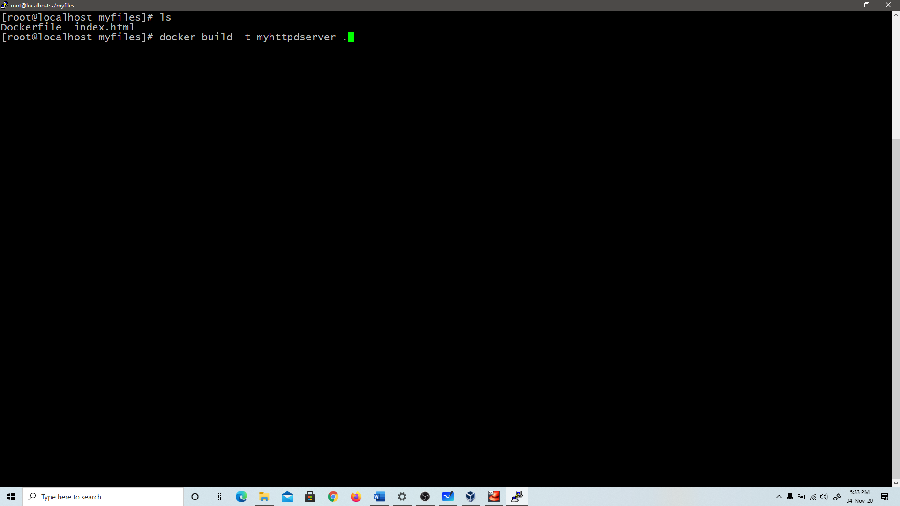

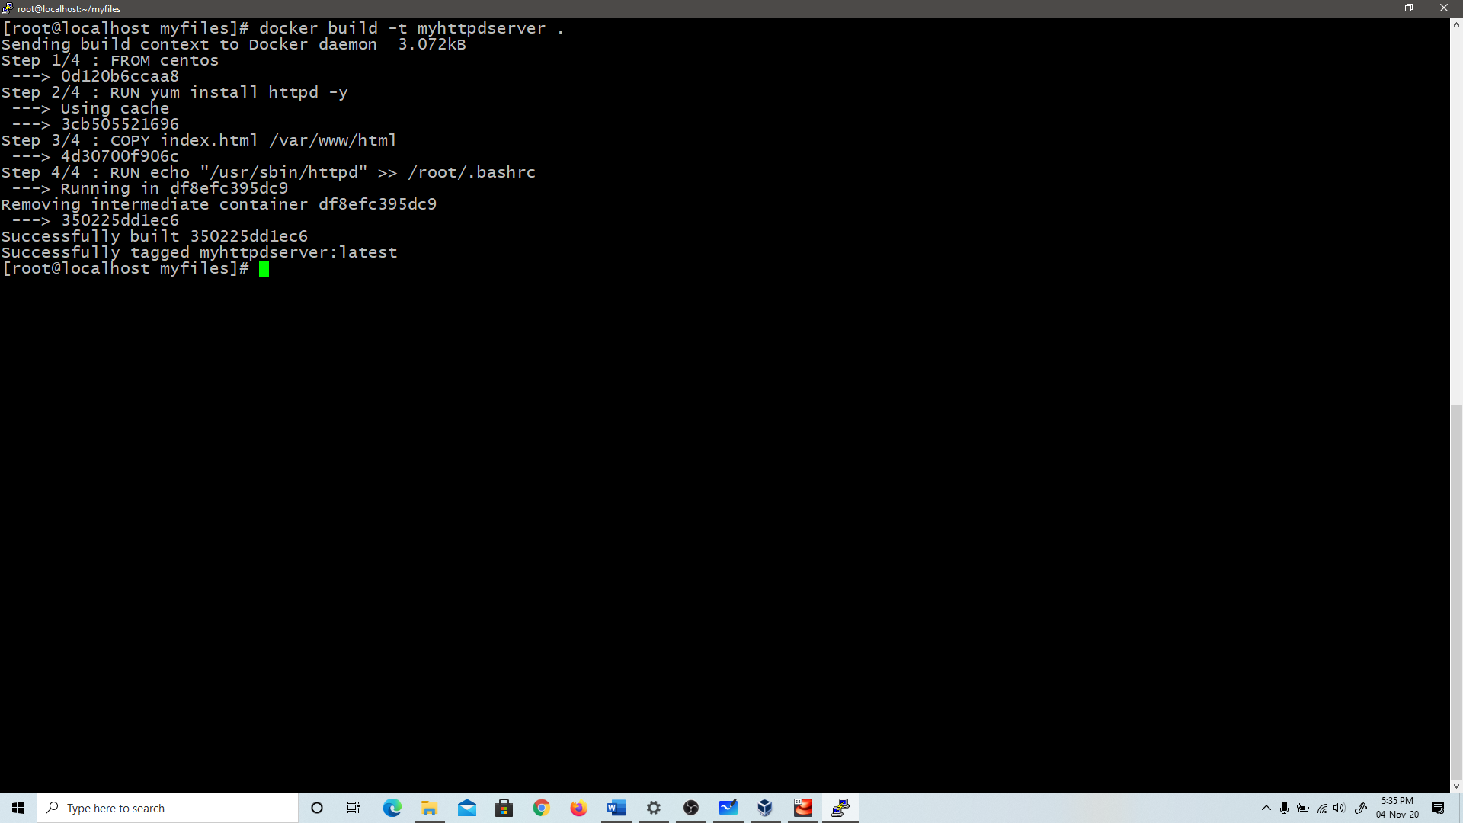

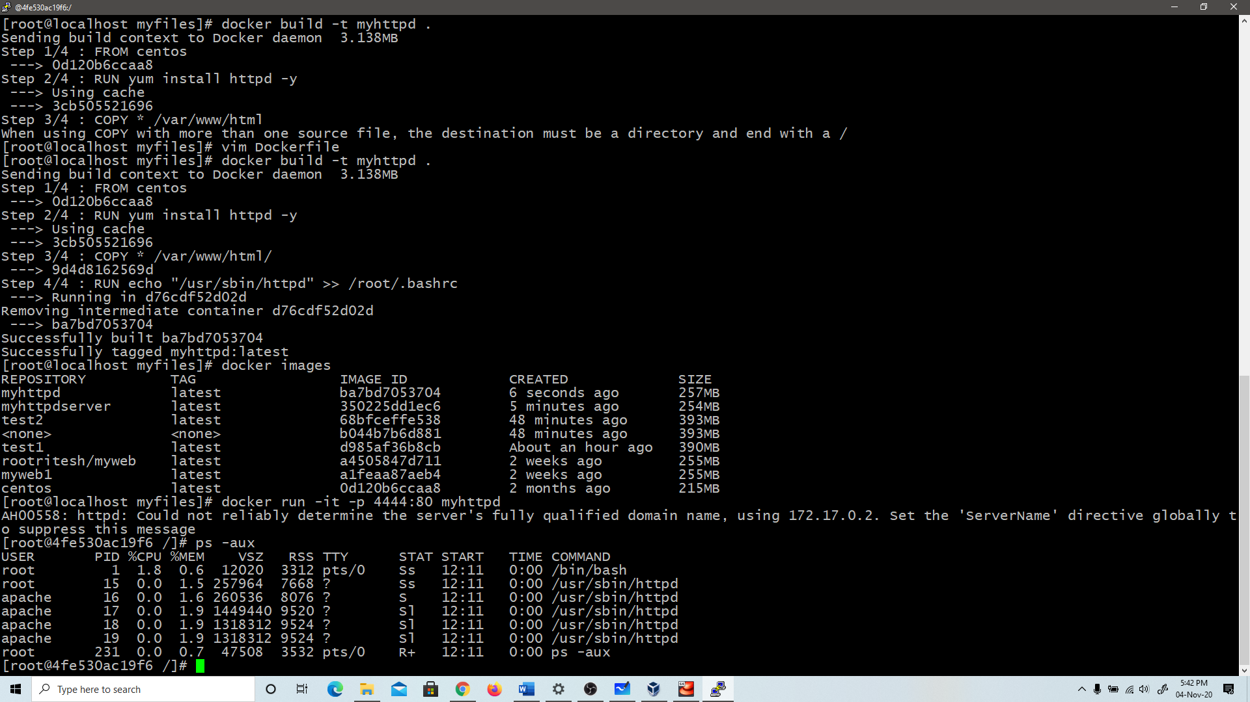

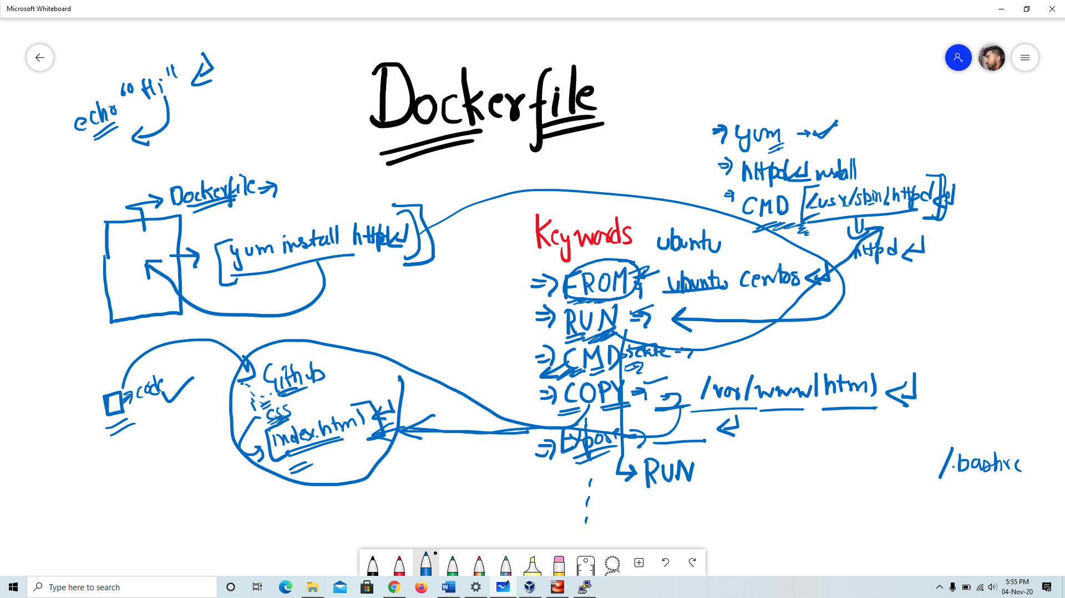

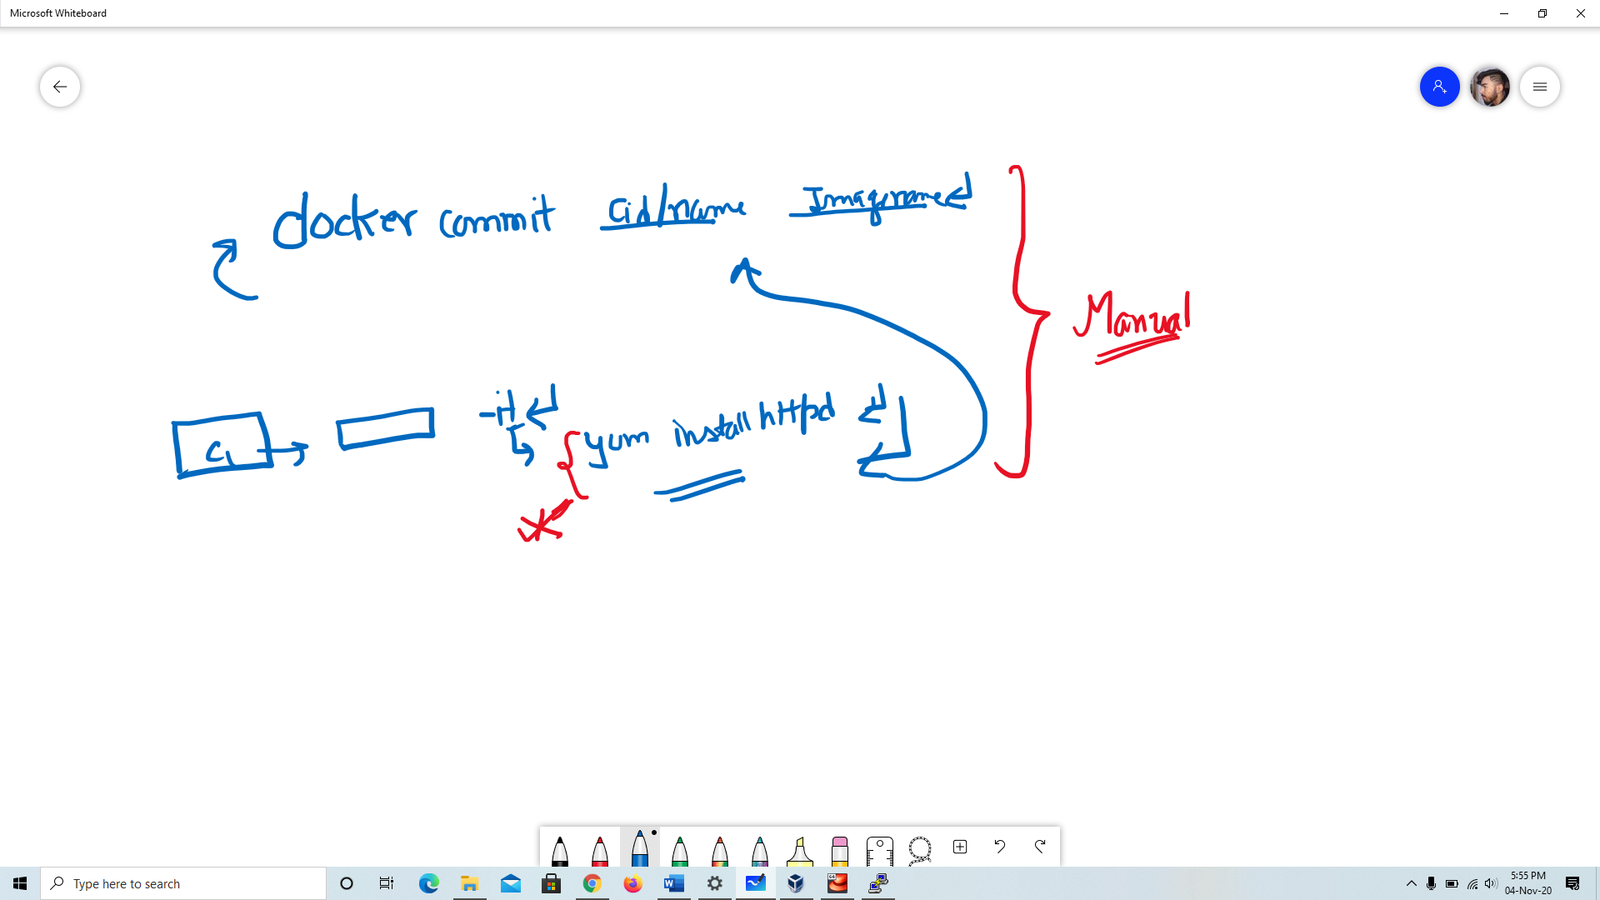

**Dockerfile:**

**FROM centos**

**RUN yum install httpd -y**

**COPY * /var/www/html/**

**RUN echo "/usr/sbin/httpd" >> /root/.bashrc**